Supplementary Files
Table S1. Description of fishing mortality (F) configuration options available in the SPASAM-MSE framework. These options allow users to define initial F, select among historical fishing patterns, or provide user-specified F values.
Option | Description
F.year1 | Fishing mortality in the first year
Fhist | Pattern of historical fishing mortality. Available options:
 | “constant”: Constant across years
 | “updown”: Increase to “Fmax” until change point, then decrease to “Fmin”
 | “downup”: Decrease to “Fmin” until change point, then increase to “Fmax”
 | “F-H-L”: Constant “F.year1 × Fmax” until change point, followed by constant “F.year1 × Fmin”
 | "F-L-H": Constant “F.year1 × Fmin” until change point, followed by constant “F.year1×Fmin”
Fmax | Maximum F (or multiplier when Fhist = "F-H-L" or Fhist = "F-L-H")
Fmin | Minimum F (or multiplier when Fhist = "F-H-L" or Fhist = "F-L-H")
change_time | Proportion of the time series (0–1) indicating when the change in fishing mortality occurs.
user_F | Optional matrix (`n_years × n_fleets`) of user-specified fishing mortality values.

Table S2. Catch apportionment strategies available in the SPASAM-MSE.
Strategy Name | Catch Allocation Methods | Equation
Equal allocation | Total catch is equally allocated across all fleets. | $$C_{t,f}=\frac{C_{t}}{N_{F}}$$
Equal by gear | Gear-specific catch is equally divided among fleets using the same gear. | $$C_{t,f}=\frac{C_{t,g}}{N_{F}(g)}, with\sum_{g=1}^{N_{G}}{C_{t,g}}=C_{t}$$
Region-weighted | Catch allocated by historical regional catch; equally split among fleets in region. | $$w_{r}=\frac{\sum_{y=t-Y}^{y=t-1}{C_{y,r}}}{\sum_{y=t-Y}^{y=t-1}{C_{y}}}$$  $$C_{t,r}=w_{r}C_{t}$$  $$C_{t,f}=\frac{C_{t,r}}{N_{G}(r)}$$
Gear-weighted | Catch allocated by historical gear-specific catch; split among regions using that gear. | $$w_{g}=\frac{\sum_{y=t-Y}^{y=t-1}{C_{y,g}}}{\sum_{y=t-Y}^{t-1}{C_{y}}}$$  $$C_{t,g}=w_{g}C_{t}$$  $$C_{t,f}=\frac{C_{t,g}}{N_{R}(g)}$$
Region × Gear weighted | Allocated based on both regional and gear-specific history. | $$w_{r}=\frac{\sum_{y=t-Y}^{y=t-1}{C_{y,r}}}{\sum_{y=t-Y}^{y=t-1}{C_{y}}}$$  $$w_{g}=\frac{\sum_{y=t-Y}^{y=t-1}{C_{y,g}}}{\sum_{y=t-Y}^{y=t-1}{C_{y}}}$$  $$C_{t,f}=w_{r}w_{g}C_{t}$$
Fleet-specific weighted | Catch allocated by historical catch of each fleet. | $$w_{f}=\frac{\sum_{y=t-Y}^{y=t-1}{C_{y,f}}}{\sum_{y=t-Y}^{y=t-1}{C_{y}}}$$  $$C_{t,f}=w_{f}C_{t}$$
Survey-based regional split | Survey-based catch allocation across regions; split equally among fleets in region. | $$w_{r}=\frac{\sum_{y=t-Y}^{y=t-1}{I_{y,r}}}{\sum_{y=t-Y}^{y=t-1}{I_{y}}}$$  $$C_{t,r}=w_{r}C_{t}$$  $$C_{t,f}=\frac{C_{t,r}}{N_{G}(r)}$$
Survey × Gear weighted | Regional survey-based weights; split among fleets by gear history. | $$w_{r}=\frac{\sum_{y=t-Y}^{y=t-1}{I_{y,r}}}{\sum_{y=t-Y}^{y=t-1}{I_{y}}}$$  $$w_{g}=\frac{\sum_{y=t-Y}^{y=t-1}{C_{y,g}}}{\sum_{y=t-Y}^{y=t-1}{C_{y}}}$$  $$C_{t,f}=w_{r}w_{g}C_{t}$$
Multi-survey index equal | Multi-survey-based allocation to regions; equally split among fleets. Catch is equally distributed among fleets within the region. | $$w_{r}=\frac{\sum_{y=t-Y}^{y=t-1}{I_{y,r}^{\left(i\right)}}}{\sum_{y=t-Y}^{y=t-1}{I_{y}^{\left(i\right)}}}$$  $$C_{t,r}=w_{r}C_{t}$$  $$C_{t,f}=\frac{C_{t,r}}{N_{G}(r)}$$
Multi-survey × Gear weighted | Allocated based on multi-survey regional index and gear-specific historical catch. | $$w_{r}=\frac{\sum_{y=t-Y}^{y=t-1}{I_{y,r}^{\left(i\right)}}}{\sum_{y=t-Y}^{y=t-1}{I_{y}^{\left(i\right)}}}$$  $$w_{g}=\frac{\sum_{y=t-Y}^{y=t-1}{C_{y,g}}}{\sum_{y=t-Y}^{y=t-1}{C_{y}}}$$  $$C_{t,f}=w_{r}w_{g}C_{t}$$
User-defined fleet weights | User provides weights for each fleet. | $$C_{t,f}=w_{f}C_{t}$$
User-defined region weights | User provides weights for regions; catch is equally split among fleets in the region. | $$C_{t,r}=w_{r}C_{t}$$  $$C_{t,f}=\frac{C_{t,r}}{N_{G}(r)}$$
Note:
- $C_{t}$: Total catch in year $t$.
- $C_{t,f}$: Catch allocated to fleet $f$ in year $t$.
- $C_{t,r}$: Catch allocated to region $r$ in year $t$.
- $C_{t,g}$: Total catch for gear type $g$ in year $t$.
- $I_{y,r}$: Survey catch for region $r$ in year y.
- $I_{y}$: Survey total catch in year y.
- $I_{y,r}^{\left(i\right)}$: Survey $i$ catch for region $r$ in year y.
- $N_{G}$: Total number of gear types.
- $N_{F}$: Total number of fleets.
- $N_{R}$: Total number of regions.
- $N_{F}(g)$: Total number of fleets using gear type $g$.
- $N_{G}(r)$: Total Number of gear types in region $r$.
- $w_{f}$: Weight assigned to fleet $f$.
- $w_{r}$: Weight assigned to region $r$.
- $w_{g}$: Weight assigned to gear type $g$.
- $Y$: Number of years used for calculating the average.
Table S3. Summary of performance metrics available in SPASAM-MSE. Reported values of F and SSB are from the operating model (OM), although corresponding estimates are also available from each estimation model (EM) during the feedback loop. Catch values represent removals from the OM (without observation error), although catch including observation error are also available.
Performance Metric | Equation | Description
Short-term Average Catch | $$\frac{1}{k}\sum_{y=1}^{k}{{{Catch}_{y}}^{\left(t\right)}|t=1,…,N}$$ | Average catch over the first k years of the feedback period. Summarized across N realizations using the mean or median.
Short-term Average Fully Selected F | $$\frac{1}{k}\sum_{y=1}^{k}{{F_{y}}^{\left(t\right)}}|t=1,…,N$$ | Average fully selected F over the first k years of the feedback period. Summarized across N realizations using the mean or median.
Short-term Average SSB | $$\frac{1}{k}\sum_{y=1}^{k}{{{SSB}_{y}}^{\left(t\right)}|t=1,…,N}$$ | Average SSB over the first k feedback period. Summarized across N realizations using the mean or median.
Long-term Average Catch | $$\frac{1}{m}\sum_{y=n-m+1}^{n}{{{Catch}_{y}}^{(t)}}|t=1,…,N$$ | Average catch over the last $m$ years of the feedback period. Summarized across N realizations using the mean or median.
Long-term Average Fully Selected F | $$\frac{1}{m}\sum_{y=n-m+1}^{n}{{F_{y}}^{\left(t\right)}|t=1,…,N}$$ | Average fully selected fishing mortality over the last $m$ years of the feedback period. Summarized across N realizations using the mean or median.
Long-term Average SSB | $$\frac{1}{m}\sum_{y=n-m+1}^{n}{{{SSB}_{y}}^{\left(t\right)}|t=1,…,N}$$ | Average SSB over the last m years of the feedback period. Summarized across N realizations using the mean or median.
Relative Difference in Short-term Average Catch | $$\frac{1}{k}\sum_{y=1}^{k}{(\frac{{{Catch}_{y,EM}}^{\left(t\right)}-{{Catch}_{y,baseline}}^{\left(t\right)}}{{{Catch}_{y,EM}}^{\left(t\right)}})|t=1,…,N}$$ | Average relative differences in catch between a candidate EM and a baseline EM over the first k years of the feedback period. Summarized across N realizations using the mean or median.
Relative Difference in Short-term Average Fully Selected F | $$\frac{1}{k}\sum_{y=1}^{k}{(\frac{{F_{y,EM}}^{\left(t\right)}-{F_{y,baseline}}^{\left(t\right)}}{{F_{y,EM}}^{\left(t\right)}})|t=1,…,N}$$ | Average relative differences in F between a candidate EM and a baseline EM over the first k years of the feedback period. Summarized across N realizations using the mean or median.
Relative Difference in Short-term Average SSB | $$\frac{1}{k}\sum_{y=1}^{k}{(\frac{{{SSB}_{y,EM}}^{\left(t\right)}-{{SSB}_{y,baseline}}^{\left(t\right)}}{{{SSB}_{y,EM}}^{\left(t\right)}})|t=1,…,N}$$ | Average relative differences in SSB between a candidate EM and a baseline EM over the first k years of the feedback period. Summarized across N realizations using the mean or median.
Relative Difference in Long-term Average Catch | $$\frac{1}{m}\sum_{y=n-m+1}^{n}{(\frac{{{Catch}_{y,EM}}^{\left(t\right)}-{{Catch}_{y,baseline}}^{\left(t\right)}}{{{Catch}_{y,EM}}^{\left(t\right)}})|t=1,…,N}$$ | Average relative differences in Catch between a candidate EM and a baseline EM over the last $m$ years of the feedback period. Summarized across N realizations using the mean or median.
Relative Difference in Long-term Average Fully Selected F | $$\frac{1}{m}\sum_{y=n-m+1}^{n}{(\frac{{F_{y,EM}}^{\left(t\right)}-{F_{y,baseline}}^{\left(t\right)}}{{F_{y,EM}}^{\left(t\right)}})|t=1,…,N}$$ | Average relative differences in F between a candidate EM and a baseline EM over the last $m$ years of the feedback period. Summarized across N realizations using the mean or median.
Relative Difference in Long-term Average SSB | $$\frac{1}{m}\sum_{y=n-m+1}^{n}{(\frac{{{SSB}_{y,EM}}^{\left(t\right)}-{{SSB}_{y,baseline}}^{\left(t\right)}}{{{SSB}_{y,EM}}^{\left(t\right)}})|t=1,…,N}$$ | Average relative differences in $SSB$ between a candidate EM and a baseline EM over the last $m$ years of the feedback period. Summarized across N realizations using the mean or median.
Probability of Overfishing | $$P_{(t)}=\frac{1}{n}\sum_{y=1}^{n}{I}\left(\frac{{F_{y}}^{t}}{{F_{MSY_{y}}}^{t}}>1\right)|t=1,…,N$$ | Proportion of years where F is over $F_{MSY}$ or the proxy. Summarized across N realizations using the mean or median.
Probability of Overfished | $$P_{(t)}=\frac{1}{n}\sum_{y=1}^{n}{I}\left(\frac{{SSB_{y}}^{t}}{S{SB_{MSY_{y}}}^{t}}<0.5\right)|t=1,…,N$$ | Proportion of years where SSB is below $SSB_{MSY}$ or the proxy. Summarized across N realizations using the mean or median.
Overfishing Status | $$\frac{1}{n}\sum_{y=1}^{n}{\frac{{F_{y}}^{(t)}}{{F_{MSY_{y}}}^{(t)}}|t=1,…,N}$$ | Overfishing status over n years summarized over N realizations. Summarized across N realizations using the mean or median.
Overfished Status | $$\frac{1}{n}\sum_{y=1}^{n}{\frac{{SSB_{y}}^{(t)}}{{SSB_{MSY_{y}}}^{(t)}}|t=1,…,N}$$ | Overfished status over n years. Summarized across N realizations using the mean or median.
Average Annual Catch Variation | $$\frac{\sum_{y=2}^{n}{\left|{{Catch}_{y}}^{(t)}-{{Catch}_{y-1}}^{(t)}\right|}}{\sum_{y=2}^{n}{{{Catch}_{y-1}}^{(t)}}}|t=1,…,N$$ | Interannual variability in catch. Summarized across N realizations using the mean or median.
Average Annual F Variation | $$\frac{\sum_{y=2}^{n}{\left|{F_{y}}^{(t)}-{F_{y-1}}^{(t)}\right|}}{\sum_{y=2}^{n}{{F_{y-1}}^{(t)}}}|t=1,…,N$$ | Interannual variability in F. Summarized across N realizations using the mean or median.
Average Annual SSB Variation | $$\frac{\sum_{y=2}^{n}{\left|{{SSB}_{y}}^{(t)}-{{SSB}_{y-1}}^{(t)}\right|}}{\sum_{y=2}^{n}{{{SSB}_{y-1}}^{(t)}}}|t=1,…,N$$ | Interannual variability in SSB. Summarized across N realizations using the mean or median.
Relative Bias in Model Parameter | $$\frac{{\hat{β}}^{(t)}-β}{β}|t=1,…,N$$ | Relative bias of the estimated model parameter $\hat{β}$ to the true model parameter $β$. Summarized across N realizations using the mean or median.
Mean Relative Bias in Management Quantity | $$\frac{1}{n}\sum_{y=1}^{n}{\frac{{\hat{θ_{y}}}^{(t)}-{θ_{y}}^{(t)}}{{θ_{y}}^{(t)}}}|t=1,…,N$$ | Mean relative bias of the estimated management quantity $\hat{θ}$ compared to the true management quantity $θ$ over years. Summarized across N realizations using the mean or median.
Score for Catch and SSB Related Performance Metrics | $$\frac{{{Metric}_{y, EM}}^{\left(t\right)}-{min⁡({Metric}_{y,EM}}^{\left(t\right)})}{{max⁡({Metric}_{y,EM}}^{\left(t\right)})-{min⁡({Metric}_{y,EM}}^{\left(t\right)})}|t=1,…,N$$ | Normalized performance scores for each realization, scaled from 0 (worst) to 1 (best) across EMs. Summarized across N realizations using mean or median.
Score for F and Annual Variation Related Performance Metrics | $$1-\frac{{{Metric}_{y, EM}}^{\left(t\right)}-{min⁡({Metric}_{y,EM}}^{\left(t\right)})}{{max⁡({Metric}_{y,EM}}^{\left(t\right)})-{min⁡({Metric}_{y,EM}}^{\left(t\right)})}|t=1,…,N$$ | Inverse normalized performance scores for each realization, scaled from 0 (worst) to 1 (best) across EMs. Summarized across N realizations using mean or median.

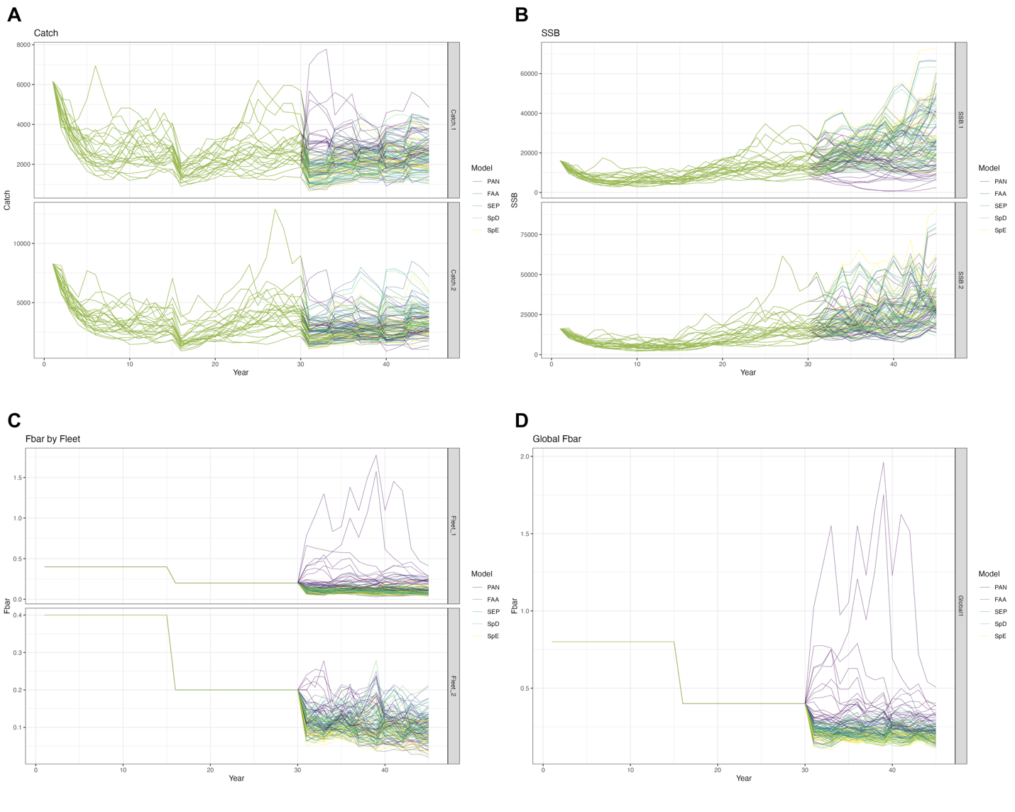
Figure S1. Trajectories of (A) catch, (B) spawning stock biomass (SSB), and (C-D) fishing mortality (F) from all estimation models (EMs), across 25 realizations.
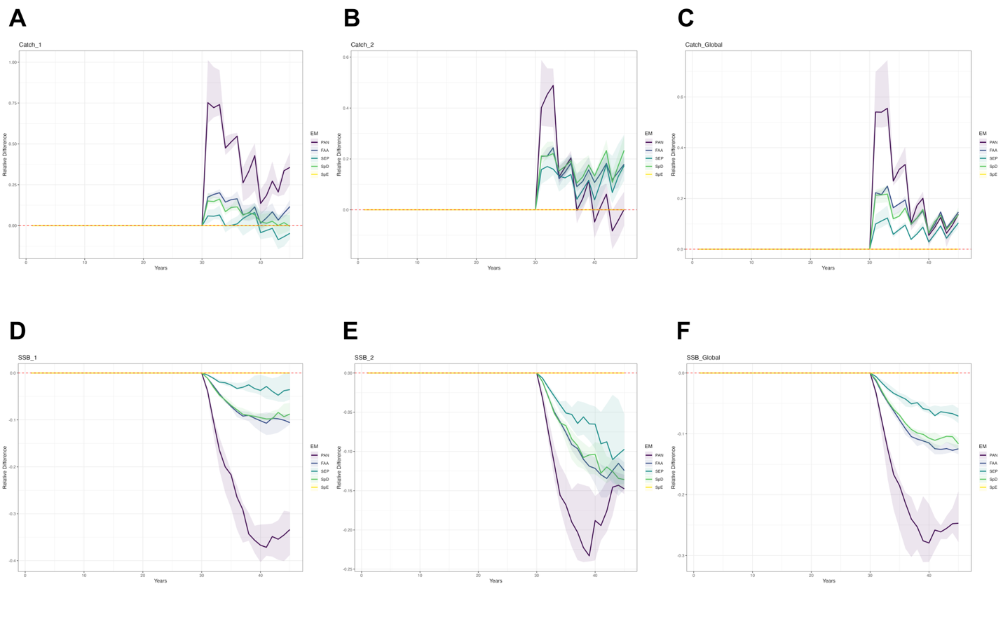Figure S2. Annual differences in catch and spawning stock biomass (SSB) relative to the spatially explicit EM (SpE), at both regional and global scales. Results are summarized across 25 realizations. Lines indicate the median values, and shaded areas represent the interquantile range from the 40th to 60th percentiles.

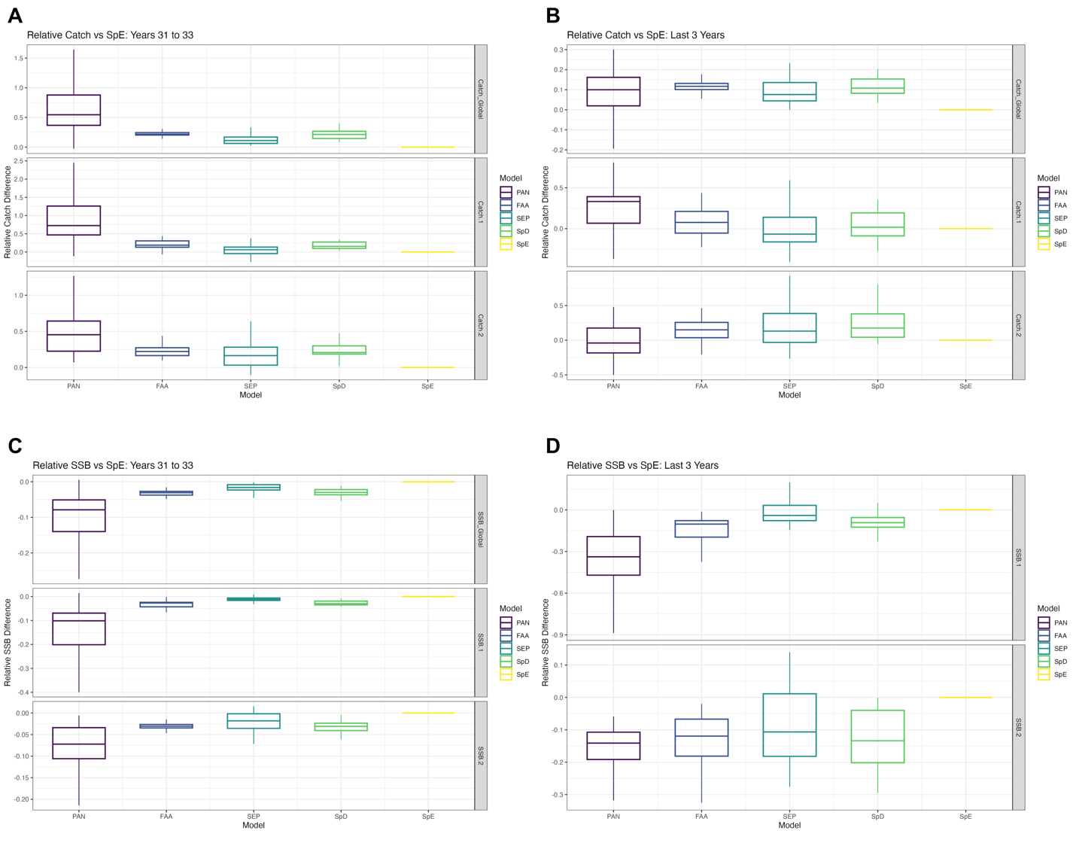
Figure S3. Relative performance of estimation models (EMs) for short-term and long-term catch and spawning stock biomass (SSB), compared to the spatially explicit EM (SpE). For each realization, mean catch or mean SSB was calculated over the evaluation window (short term = first 3 years; long term = last 3 years of the feedback loop). Values for each EM were then expressed relative to the corresponding SpE value within the same realization, such that values >0 indicate better performance than SpE and values <0 indicate worse performance. Panels show relative performance for short-term average catch (A), short-term average SSB (B), long-term average catch (C), and long-term average SSB (D). Boxplots summarize the distribution of these relative performance values across 25 realizations: horizontal lines indicate medians, boxes represent the interquartile range (25th–75th percentiles), and whiskers extend to 1.5× the interquartile range.
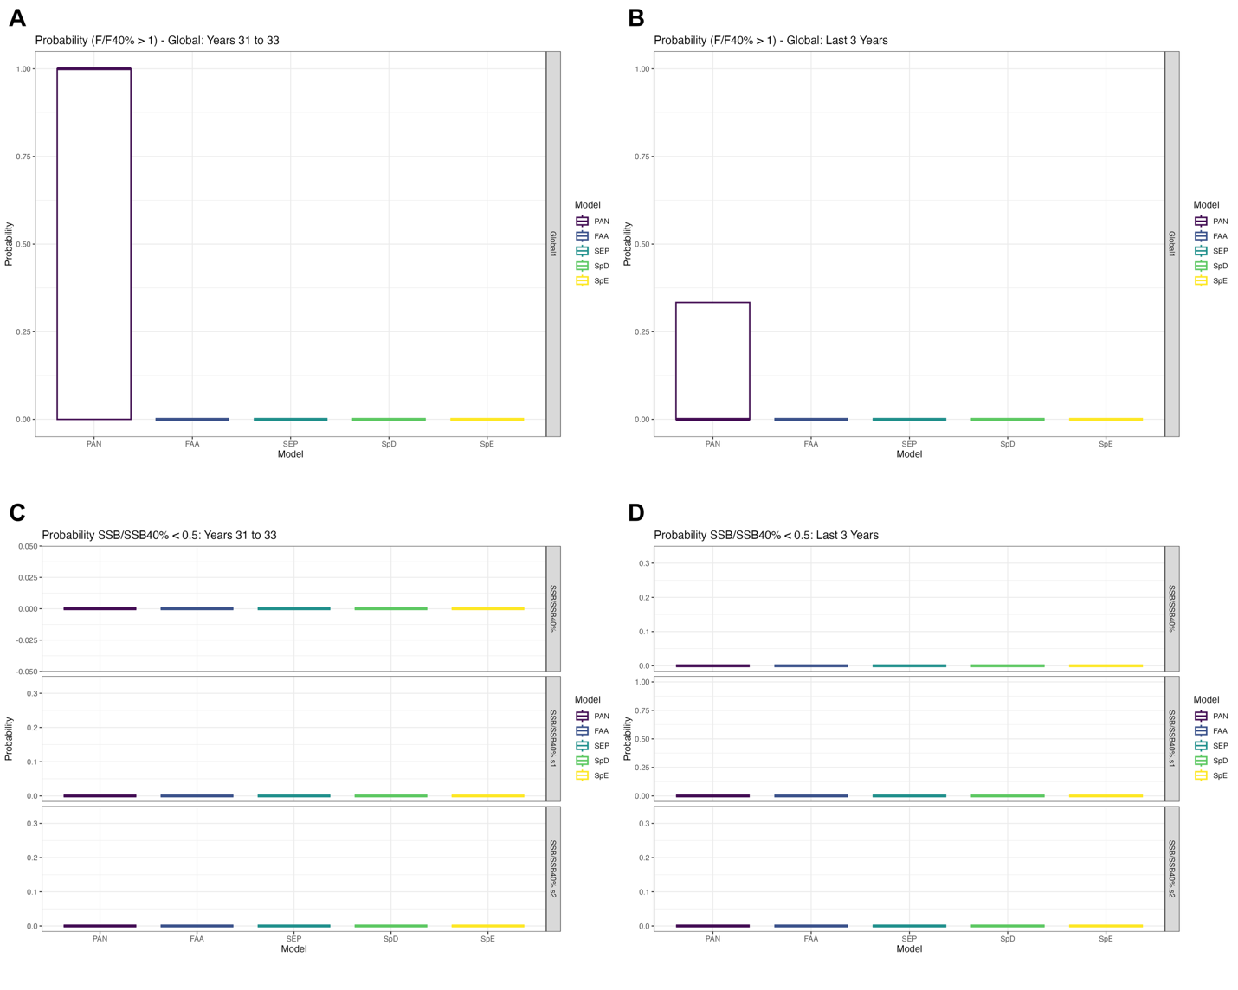
Figure S4. Probability of (A) overfishing in the short-term and (B) long-term, and probability of being overfished in the short-term (C) and long-term (D), across all estimation models (EMs). Results are summarized over 25 realizations. Boxplots show the median and interquartile range (25th–75th percentiles), with whiskers extending to 1.5 times the interquartile range.
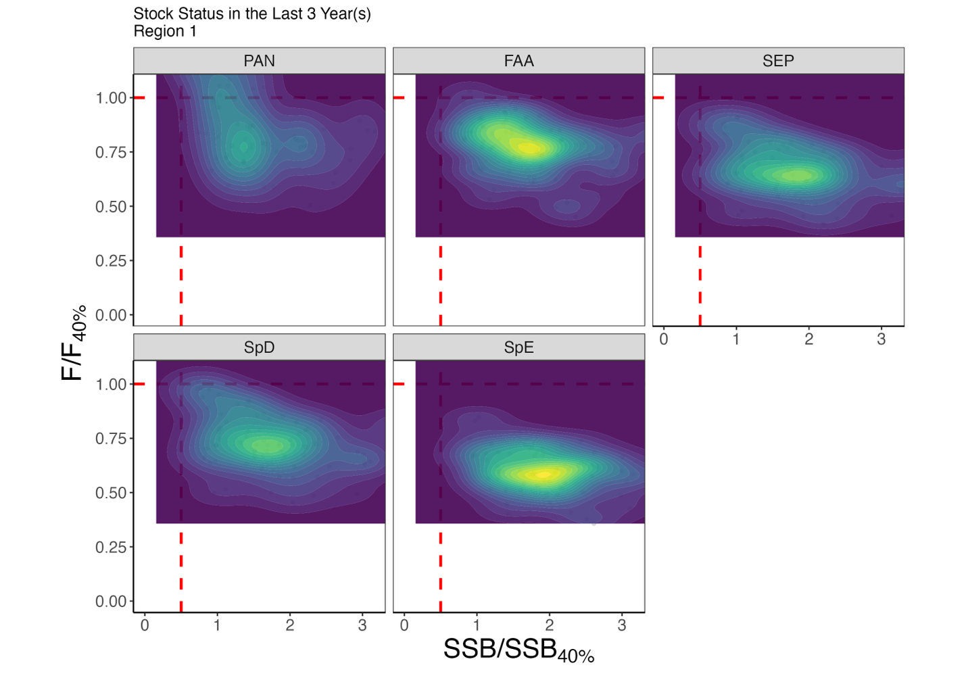
Figure S5. Kobe plot illustrating the population status in Region 1 over the last 3 years of the feedback period for each estimation model (EM), summarized across 25 realizations.
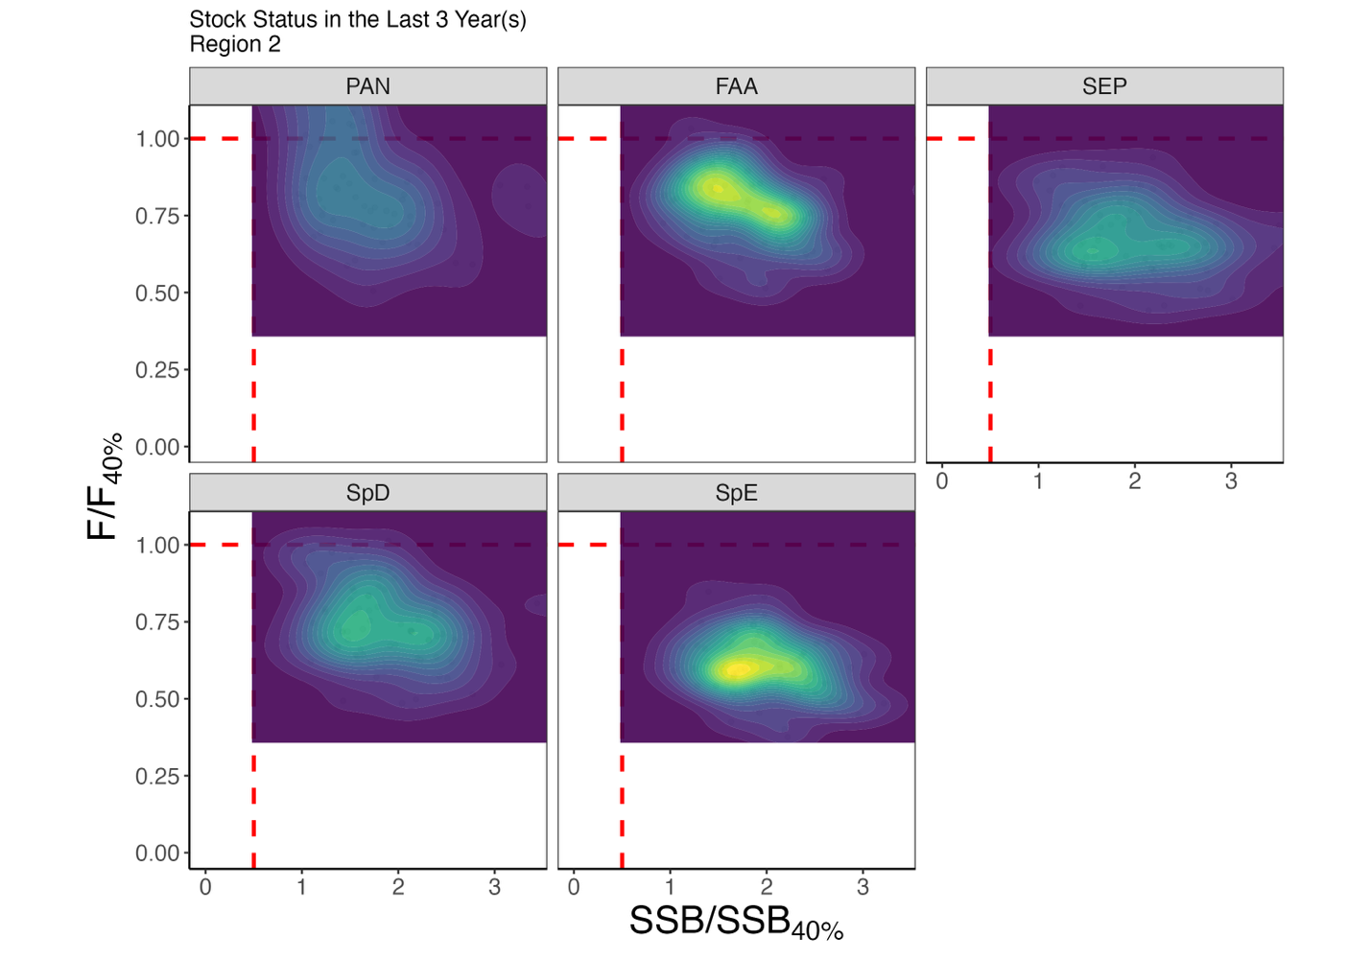
Figure S6. Kobe plot illustrating the population status in Region 2 over the last 3 years of the feedback period for each estimation model (EM), summarized across 25 realizations.
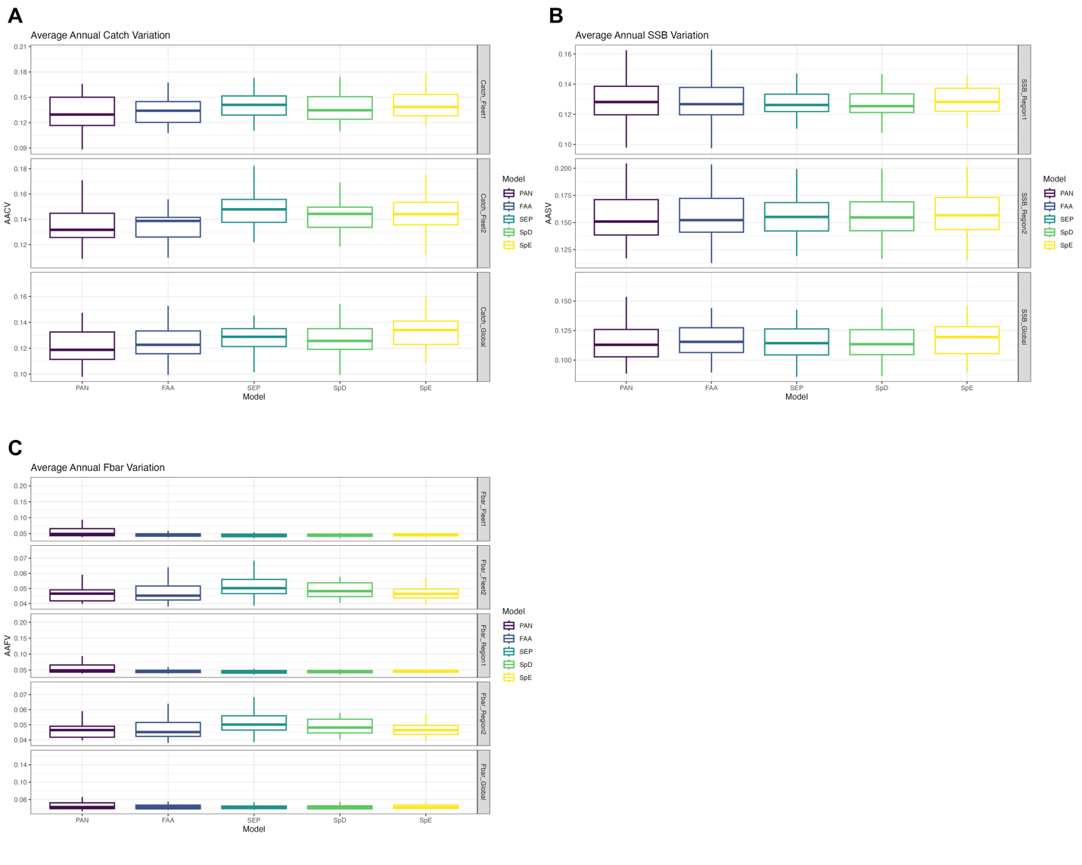
Figure S7. Annual average variation in catch, fishing mortality (F), and spawning stock biomass (SSB) at both regional and global scales, calculated over the entire feedback period. Results are summarized across all estimation models (EMs) and 25 realizations. Boxplots show the median and interquartile range (25th–75th percentiles), with whiskers extending to 1.5 times the interquartile range.

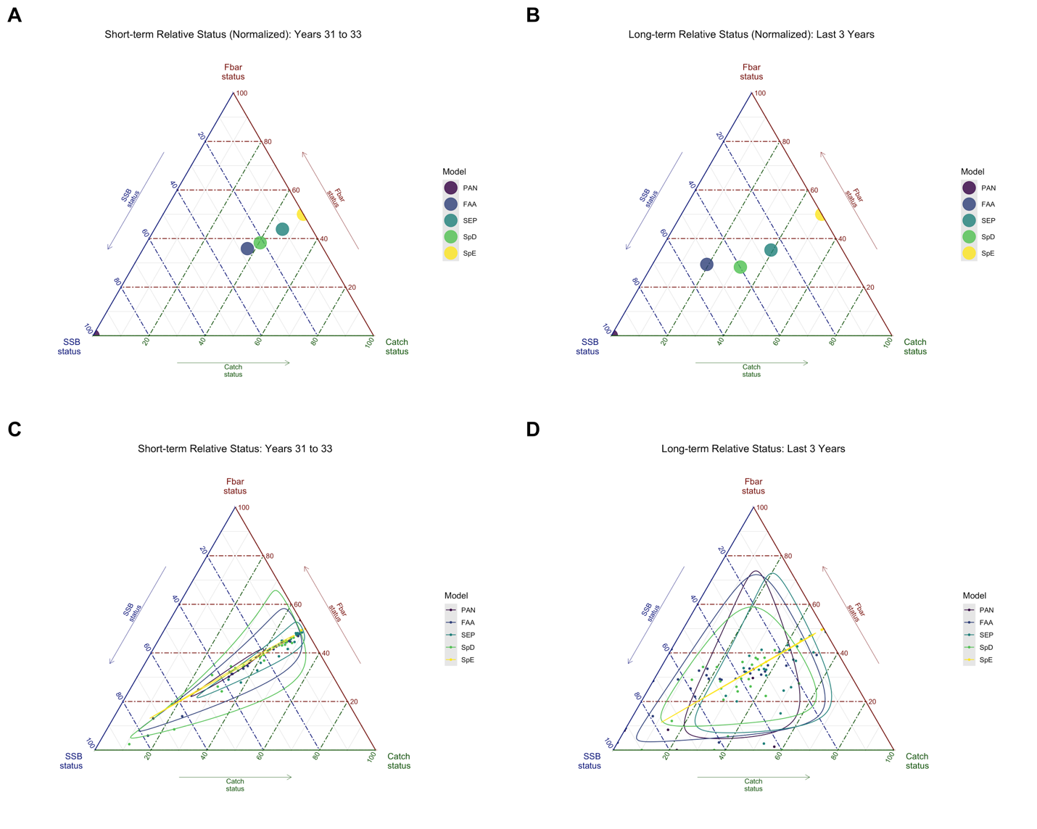
Figure S8. Ternary plots illustrating the trade-offs among three global performance metrics: annual average catch variation (AACV), total catch, and spawning stock biomass (SSB), for each estimation model (EM). Scores were normalized within each realization and inverted for AACV so that higher values consistently represent better performance. Panels A and C show short-term results, and panels B and D show long-term results. In panels A and B, each point represents the median normalized score across 25 realizations per EM. Panels C and D display all raw points from the 25 realizations per EM, along with 95% confidence regions. These plots highlight both central tendencies and variability in model performance across trade-off dimensions.

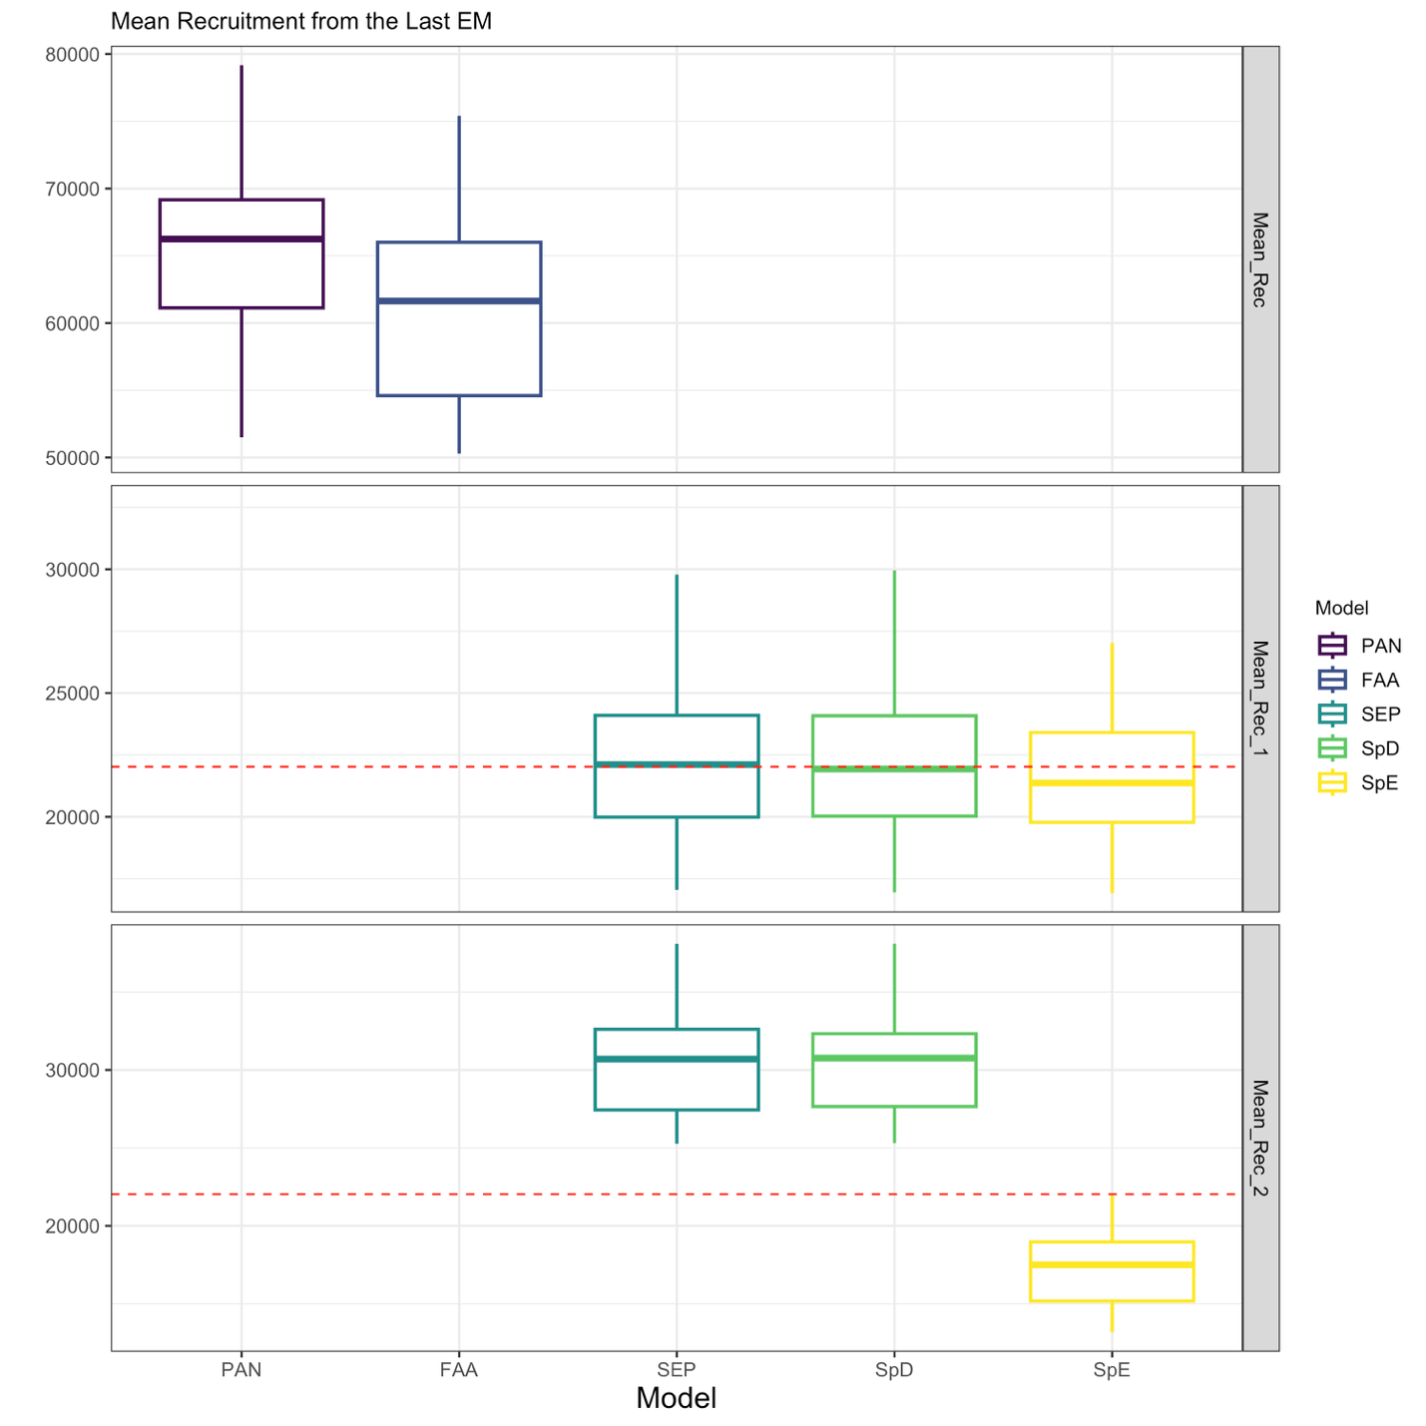
Figure S9. Mean recruitment estimates from each estimation model (EM) based on the final assessment within the feedback period. For panmictic models (PAN and FAA), only global mean recruitment is estimated, while all other EMs estimate region-specific mean recruitment. The red line indicates the true mean recruitment from the operating model (OM). Boxplots show the median and interquartile range (25th–75th percentiles), with whiskers extending to 1.5 times the interquartile range.
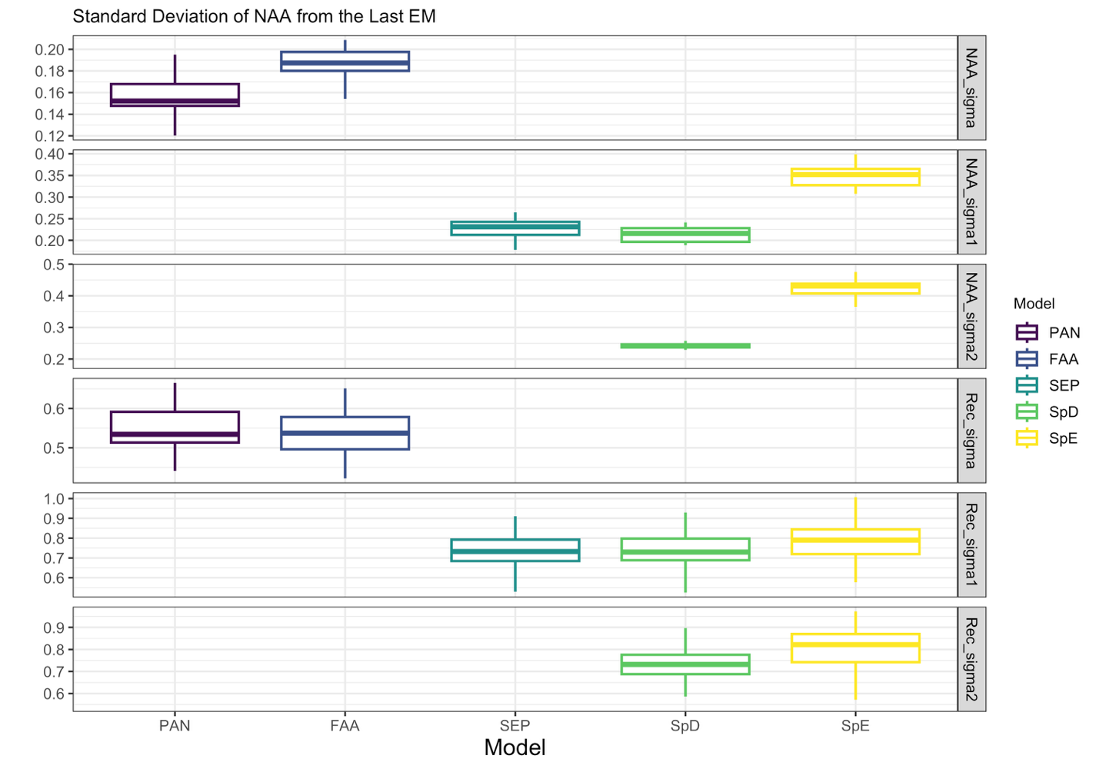
Figure S10. Standard deviation of numbers-at-age (NAA) transitions estimated from each estimation model (EM) based on the final assessment within the feedback period. For panmictic models (PAN and FAA), only global NAA standard deviations were estimated. For all other EMs, region-specific NAA standard deviations were estimated. Boxplots show the median and interquartile range (25th–75th percentiles), with whiskers extending to 1.5 times the interquartile range.

